

Ramdeobaba University, Nagpur

Electronics and Communication Engineering Department

4th Semester B.Tech. Session-2025-26

Topic:Personalized Burnout Recovery Planner
Multi-Agent AI System

Project Group Students:
- Mohit Yeole (14., A)
- Aahana Kapse (36., A)

Section 1 — Problem Statement
The main idea behind this project came from a simple observation — a lot of people, especially students and working professionals, go through burnout at some point. And when they try to find help, they usually end up reading the same generic advice that does not account for their actual situation. This project is an attempt to fix that using a multi-agent AI pipeline.

1.1 Who Are the Users?
The target users are roughly aged 18 to 40 — mostly students under academic pressure and people working in demanding jobs. Some specific examples:

- Software engineers who are always on-call, working in sprint cycles, and dealing with constant context-switching.
- Students trying to manage multiple deadlines, exams, and financial stress at the same time.
- Managers who spend the whole day making decisions and switching between team responsibilities.
- Remote workers who have lost the boundary between working hours and personal time.

What all of these people have in common is that they know something is wrong — they feel tired all the time, unmotivated, irritable — but they do not know exactly where to start recovering. They google things, find an article about "10 tips for burnout", try it for two days, feel guilty when they cannot follow it, and give up.

1.2 The Problem with Existing Solutions
Generic burnout advice fails not because the advice itself is wrong, but because it does not account for who the person actually is. There are four specific reasons for this:

Trigger Blindness
Different people burn out for completely different reasons. Someone exhausted from constant Slack notifications has a very different problem than someone burning out from loneliness or financial anxiety. Generic advice treats all burnout as the same thing, which is why it often does not help.
Constraint Blindness
A person with two young children physically cannot do 30 minutes of morning meditation. A student with no income cannot take a week off. When advice ignores these real-world constraints, people feel guilty for not being able to follow it, which makes things worse, not better.
Static Knowledge
Wellness articles and apps are written at a point in time and stay that way. Research in areas like occupational health, sleep science, and cognitive behavioural therapy keeps evolving. A static resource cannot reflect what is being recommended by researchers and therapists right now.

No Way to Check Quality
A blog post or a wellness app has no way of evaluating whether the plan it gave you actually fits your situation. It just produces output and moves on. There is no feedback loop, no scoring, no check on whether the advice is even relevant.

1.3 What This Project Does Differently
This project addresses each of those four problems directly:

Problem | How the system handles it
Trigger blindness | The user fills in a free-text profile describing their specific stressors. The agents work from that, not from generic assumptions.
Constraint blindness | The Habit Analyzer agent reads the user's profile and explicitly maps each technique to their actual lifestyle and constraints.
Static knowledge | The Researcher agent uses Tavily to do live web searches and pull current, up-to-date evidence rather than relying on training data.
No quality check | The Judge agent independently evaluates the final plan on 5 criteria and assigns scores — it was not involved in writing the plan.

1.4 Why Use a Multi-Agent Pipeline Instead of Just a Chatbot?
A basic chatbot can take your description and spit out a burnout recovery plan in one shot. The problem is that this kind of output has no grounding — it comes entirely from the model's training data, it cannot verify what it produced, and it cannot check whether the advice actually fits the person.

Using a sequential pipeline with multiple agents solves these issues because each agent has a specific job and operates on the verified output of the agent before it. Here is the reasoning for each agent:

- The Researcher agent runs a multi-turn loop where it actively decides what to search for based on the user's triggers. It can run up to 8 search turns, which is something a single prompt simply cannot do.
- The Habit Analyzer does not write anything — its only job is to reason about which techniques from the research actually fit this particular person. This separation of concerns means the final plan is based on explicit matching, not intuition.
- The Plan Writer is constrained to work only from the research brief and habit analysis produced by the earlier agents. It cannot invent techniques that were not already established upstream.
- The Judge evaluates the final plan independently — it had no role in writing it, so its evaluation is not biased toward approving its own work. This is what makes the quality score actually meaningful.
- If any of the LLM calls fail (quota exceeded, API error), each agent falls back to a deterministic rule-based output. The system never crashes and always produces something usable.

The result is a plan that is more current (live search), more personalized (profile-aware reasoning), more verifiable (independent quality scoring), and more robust (graceful fallbacks) than what a single-prompt chatbot approach can achieve.

Section 2 — Task Decomposition

The system runs as a sequential pipeline. Each task below takes specific inputs, produces specific outputs, and has defined behaviour for when things go wrong. The pipeline runs inside a Streamlit web application, with app.py handling orchestration and agents.py containing the agent logic.

Inputs and Outputs — Overall
What the user provides
- A free-text description of their situation — this is called user_profile throughout the code. It should cover their work situation, what is stressing them, their sleep and lifestyle, and what they want to achieve.
- GEMINI_API_KEY — the Google Gemini API key, set as an environment variable.
- TAVILY_API_KEY — the Tavily search API key, also an environment variable.

What the user sees in the output
The app shows four tabs once the pipeline finishes:

Tab | What it contains | Which agent produced it
Research Brief | A markdown report summarising current, evidence-based recovery techniques | Agent 1 (Researcher)
Habit Analysis | An analysis of which techniques fit the user and why | Agent 2 (Habit Analyzer)
21-Day Plan | A day-by-day recovery plan split into 3 phases | Agent 3 (Plan Writer)
Quality Review | Scores on 5 criteria, shown with a ring chart | Agent 4 (Judge)

Environment Setup
Before any agent runs, the system checks that the necessary API keys are available and initialises the clients. This happens at the top of app.py.

Inputs
- GEMINI_API_KEY from the environment
- TAVILY_API_KEY from the environment
Outputs
- client — the Gemini client object (or None if the key is missing)
- tavily_client — the Tavily client object
- A warning banner in the UI if a key is missing

What happens in different cases
- If GEMINI_API_KEY is missing: client is set to None, a warning is shown, and all agents switch to fallback mode automatically.
- If TAVILY_API_KEY is missing: a warning is shown; the Researcher agent will not be able to search.
- If both keys are present: the pipeline runs normally.

Taking in the User's Profile
This is where the user enters their information. There is a text area in the Streamlit UI and a submit button. This is handled in the form section of app.py.

Inputs
- The raw text the user types into the form
- The submit button click event
Outputs
- user_profile — a cleaned string that gets passed to all four agents
- An error message if the form was submitted empty
What happens in different cases
- If the profile is empty when submitted: show an error and stop — do not start the pipeline.
- If the profile has text: start running the agents in order.

Agent 1: Researcher
This agent searches the web for current, evidence-based burnout recovery techniques that are relevant to the user's specific situation. It uses a function-calling loop so that it can run multiple searches, not just one. This agent is defined as burnout_researcher_agent() in agents.py.

Inputs
- client — the Gemini client
- tavily_client — the Tavily client
- user_profile — the user's description
Output
- research_brief — a markdown string with sourced techniques and evidence summaries
How it works step by step
- Build an initial prompt asking the model to research burnout recovery based on the user's specific triggers.
- Register the Tavily search function as a tool the model can call (this is the function declaration / tool schema step).
- Start a multi-turn loop that runs for a maximum of 8 turns:
  - Send the current conversation history to gemini-2.0-flash along with the tool definition.
  - If the model responds with a function call: run the Tavily search using the query the model chose, add the results back into the conversation, and loop again.
  - If the model responds with plain text: the research is done — exit the loop and return that text.
- Return the final text as the research brief.
Decision points
- Model calls the search tool → run the search and continue the loop
- Model produces text → exit loop and return
- 8 turns reached → return whatever the model has produced so far
- AgentExecutionError (quota or API failure) → caught in app.py, fallback runs instead
Fallback
If the LLM call fails, fallback_research_brief() runs instead. It extracts the stress triggers from the user's text, runs up to 3 direct Tavily searches without any LLM synthesis, appends some built-in guidance, and returns a usable markdown report.

Agent 2: Habit Analyzer
This agent takes the research output and the user's profile and figures out which techniques actually fit this particular person — and which ones do not. It does not write a recovery plan; its only job is the matching and reasoning step. This is habit_analyzer_agent() in agents.py.

Inputs
- client — the Gemini client
- research_brief — the output from T2
- user_profile — the user's description
Output
- habit_analysis — a markdown string that covers: the burnout patterns identified in the user's profile, which techniques are a good fit and why, which techniques were excluded and why, and what planning approach suits the user's energy level.
How it works step by step
- Build a prompt that combines the user profile and the research brief.
- Send a single-turn request to gemini-2.0-flash using the HABIT_ANALYZER_SYSTEM_PROMPT.
- Return the response text as the habit analysis.
Decision points
- Successful response → return the habit analysis markdown
- AgentExecutionError → caught in app.py, fallback runs instead
Fallback
fallback_habit_analysis() parses the user's profile into sections using _extract_sections(), extracts the work_situation, stress_triggers, and lifestyle fields, and builds a rule-based analysis from those values.

Agent 3: Plan Writer
This agent writes the actual 21-day recovery plan. It receives the research brief and the habit analysis from the earlier agents, so it is constrained to work with evidence that has already been established — it cannot invent things. This is plan_writer_agent() in agents.py.

Inputs
- client — the Gemini client
- research_brief — output from T2
- habit_analysis — output from T3
- user_profile — the user's description
Output
recovery_plan — a markdown string with three phases:
- Phase 1 (Days 1–7): rest and stabilisation
- Phase 2 (Days 8–14): rebuilding capacity
- Phase 3 (Days 15–21): reintegration and maintenance
Each day in the plan has three things: a morning micro-habit, a main focus for the day, and an evening check-in question.
How it works step by step
- Build a prompt combining all three inputs — user profile, research brief, habit analysis.
- Send a single-turn request to gemini-2.0-flash using the PLAN_WRITER_SYSTEM_PROMPT.
- Return the response text as the recovery plan.
Decision points
- Successful response → return the 21-day plan markdown
- AgentExecutionError → caught in app.py, fallback runs instead
Fallback
fallback_recovery_plan() iterates over a hardcoded list of 21 entries, each with a morning habit, focus area, and evening question. It wraps them in week headers and returns the result as a structured markdown plan, with a note that this is a fallback template.

Agent 4: Judge
This is the evaluation step. The Judge agent scores the recovery plan that Agent 3 produced. It was not involved in writing the plan, so its evaluation is independent. It outputs structured JSON scores. This is judge_agent() in agents.py.

Inputs
- client — the Gemini client
- user_profile — the user's description
- research_brief — output from T2
- recovery_plan — output from T4
Output
judge_result — a Python dictionary with the following structure:

Field | Description
scores | A dict with 5 criteria. Each criterion has a score (0–5) and a reasoning string.
overall_score | The average of the 5 criterion scores.
summary | A short text summary of the evaluation.
top_strength | The area where the plan did best.
top_improvement | The area that most needs improvement.

The 5 criteria
Criterion | What it checks
scientific_grounding | Can all the techniques in the plan be traced back to the research brief?
personalization | Does the plan actually reflect the user's specific triggers, or is it just generic?
practicality | Are the daily habits realistic given what the user said about their lifestyle?
progression | Does the difficulty and intensity build sensibly across the three phases?
compassionate_tone | Is the language kind and supportive throughout, not prescriptive or guilt-inducing?

How it works step by step
- Format the JUDGE_EVAL_PROMPT using all three inputs.
- Send a single-turn request to gemini-2.0-flash using the JUDGE_SYSTEM_PROMPT.
- Strip any markdown code fences from the response text.
- Parse the cleaned text as JSON using json.loads().
- Return the parsed dictionary.
Decision points
- JSON parses successfully → return the result dict
- json.JSONDecodeError → return a zero-scored fallback dict with a note that parsing failed
- AgentExecutionError → caught in app.py, fallback_judge_result() runs instead
Fallback
fallback_judge_result() returns a fixed dictionary with neutral mid-range scores and a note saying the judge ran in fallback mode.

Displaying the Output
Once all four agents have run, app.py collects the results and renders them in the Streamlit UI. This is the main execution block in app.py.

Inputs
- research_brief, habit_analysis, recovery_plan — all markdown strings
- judge_result — the dictionary from T5
Outputs
- Four tabs in the UI with the content from each agent
- A score card showing the Judge's ratings as a ring chart and metric bars
- A warning banner if any agent ran in fallback mode
- A success toast when everything completes
How it works step by step
- Show a progress bar that updates as each agent finishes (0% → 35% → 60% → 82% → 100%).
- Run agents T2 through T5 in sequence. After each one finishes, log the step and update the progress bar.
- Once the pipeline is done, clear the progress placeholder.
- Render the four output tabs using st.tabs().
- Render the score card — a ring chart built as an SVG, plus individual metric bars for each criterion.
- If any fallback messages were collected during the run, show an amber warning banner listing what fell back.
How the match label is decided
Score range | Label shown
4.25 or above | Exceptional Match
3.5 to 4.24 | Strong Match
Below 3.5 | Emerging Match

What Happens When Things Break — Fallback Matrix
What goes wrong | What the system does
GEMINI_API_KEY is missing | client = None, all four agents run their fallback versions, UI shows a warning
Gemini returns a 429 (quota exceeded) | AgentExecutionError is raised, the relevant fallback function runs
Gemini returns some unexpected error | Same as above — AgentExecutionError, fallback runs
Tavily search returns no results | The researcher gets an empty snippet string and continues with the built-in guidance
The Judge's JSON cannot be parsed | A zero-scored fallback dict is returned — the app does not crash
Any other unhandled exception | Streamlit catches it, shows an error to the user, pipeline stops

One important design goal was that the system should never crash and should always produce a complete output — even if every LLM call fails, the user should still get a usable plan, a usable analysis, and usable scores.

Other Requirements Worth Noting
- The pipeline should complete in a reasonable time even on a free-tier Gemini quota.
- The Judge agent must not have any influence over the plan it evaluates — it is a separate, stateless call that runs after the plan is already finalised.
- The progress bar must update after each agent finishes, not just at the start and end.

Section 3 — Architecture Diagram

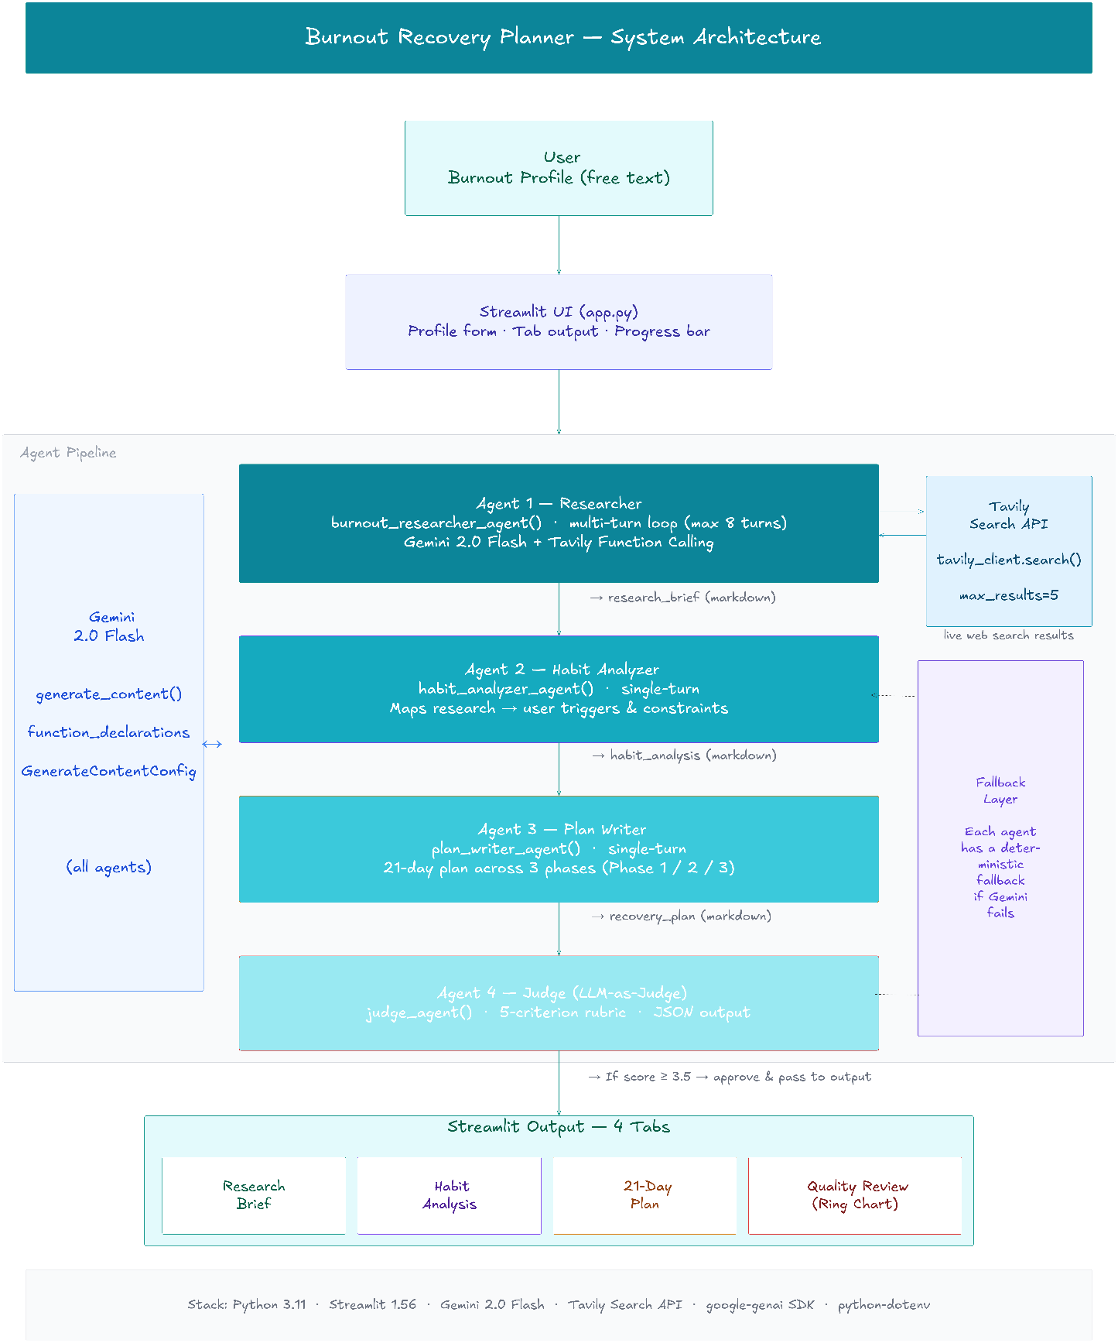
The architecture diagram for this project is maintained as an Excalidraw file in the repository (docs/architecture_diagram.excalidraw). It can be opened and edited at excalidraw.com. A PNG export of the diagram is included in the README.
Pipeline at a glance
Step | Component | What it receives | What it passes on
1 | Streamlit UI | User types their profile | user_profile string
2 | Agent 1 — Researcher | user_profile | research_brief
— | Tavily Search API | Search queries from Agent 1 | Live web search results
3 | Agent 2 — Habit Analyzer | user_profile + research_brief | habit_analysis
4 | Agent 3 — Plan Writer | user_profile + research_brief + habit_analysis | recovery_plan
5 | Agent 4 — Judge | user_profile + research_brief + recovery_plan | judge_result (JSON)
6 | Streamlit output tabs | All four outputs | Displayed to the user

File structure
File | What it does
app.py | Runs the Streamlit UI, handles the form, calls agents in order, renders output tabs and score card
agents.py | Contains all four agent functions and their fallback equivalents
prompts.py | Stores the system prompts used for each agent
requirements.txt | Lists Python dependencies
.env.example | Shows the format for the two required API keys

